DO YOU WANT UP TO THE MINUTE DRIPSTONE MIDDLE SCHOOL NOTICES SENT DIRECTLY TO YOUR PHONE?
Download our School App now.
Skoolbag delivers our school notices directly to your phone
Here’s how to install ………..
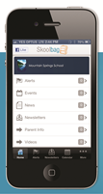
Skoolbag is a mobile app that communicates directly to parent smartphones. It provides access to key school information via one single Communication Centre for both parents and students. Ideal for:
- School free push notification alerts
- School events
- School newsletters
- School documents
- School RSS feeds
- School social media (Facebook, Twitter)

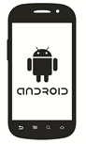
How to install Skoolbag on your Smartphone
iPhone Users
Simply search for your school name in the App Store on your phone, PC or Mac and install.
Android Users
Simply search for your school name in the Google Play Store on your phone, PC, or Mac and install.

